



­

Casestudy Document:

JQuery/JSON Developer Enablement

Level 3

Version: 1.0

Date: dd-mm-yy

Cognizant

500 Glen Pointe Center West

Teaneck, NJ 07666

Ph: 201-801-0233  
[www.cognizant.com](http://www.cognizant.com)

Contents

Solution Development for Case Study 2

Business Problem 2

Technical Requirement 2

Use Case Diagram 2

Software Checklist 3

Pre – requisite steps 3

UI Prototypes Design Requirements 4

Software Design Requirements 16

System Architecture 16

Design Considerations 16

Component Design 17

Detailed Functional Requirements 18

Java Class Diagram 22

Software Requirements Traceability Matrix 23

Evaluation Rubrics 23

Case Study Mapping to Technical Scope of Course 23

Revision History 24

# Infrastructure Section

i. Hardware, Software Specification

This section captures the hardware and software specifications for the effective delivery of the course.

1. Hardware Specification

|  |  |
| --- | --- |
| Server Specification | Windows 7 - 32bit  4GB RAM |
| Desktop / Client Specification | Admin Rights |

b. Software Specification

| # | Name of the software (s) to be installed | Version | License available in RAMS?  (Yes/No) | License available in RAMS for onsite?  (Yes/No) | Description of any patch to be installed | Can be used through Tool Wire / SoftGrid? |
| --- | --- | --- | --- | --- | --- | --- |
| 1 | JDK | 7.0 | Yes | Yes |  | Yes |
| 2 | SDE 7.0 | 7.0 | Yes | Yes |  | Yes |
| 3 | Tomcat 6.0/7.0 | 6.0/7.0 | Yes | Yes |  | Yes |
| 4 | MySQL Workbench | 6.0.8 | Yes | Yes |  | Yes |
| 5 | Netbeans 6.9.1- Complete Installation (Including Derby database and Tomcat Server) | 6.9.1 | Yes | Yes |  | Yes |
| 6 | Eclipse | 3.6 | Yes | Yes |  | Yes |
| 7 | Google Chrome | chrome | Yes | Yes |  | Yes |
| 8 | Mozilla Firefox | 3.6 and above | yes | yes | - | yes |
| 9 | Plugins – jQuery | 1.11.1.min.js | yes | yes | - | yes |
| 10 | Notepad++ | - | yes | yes | - | yes |

Instruction for installing the software in the “Tool Wire/SoftGrid” environment *(if the response is ‘Yes’ in the last column in the above table)*:

| # | Name of the software | Instruction |
| --- | --- | --- |
| 1 | jquery-1.11.1.min.js | https://jquery.com/download/ |

Installation Details:

Refer the below link for JDK and JRE installation :

<http://www.oracle.com/technetwork/java/javase/downloads/java-archive-downloads-javase6-419409.html>

Refer the below link for SE download and installation :

<https://gto.cognizant.com/javacoe/SitePages/SDEDownload.aspx>

Test Cases to check the installed software’s:

# 

# Solution Development for Case Study

## Business Problem

The Max-Store is one of the leading stores in the city. The store wants to go online to reach the customers across global and to improve the business profit. The store wants the customer to the registration before the doing the first purchase. This registered user credentials can be used for login to do the online purchase.

The store also wants to provide the online payment facility for the customer to do the payment via debit card, credit card and net banking. The store allows the customer to give their feedback which will help the store management to improvise the online service.

## Technical Requirement

As a pilot (initial release), you have been asked to add some dynamic features to this website. The exact details of the changes provided by the architect have been listed in this case study. Listed below are the screens that have to be redesigned by you.

|  |  |
| --- | --- |
| Requirement ID | Requirement Detail |
| REQ_01 | 1. Customer Registration |
| REQ_02 | 1. Online Purchase and Payment |
| REQ_03 | 1. Feedback Submission |

## Use Case Diagram

Below is the use case diagram of the system, which is planned for initial release.

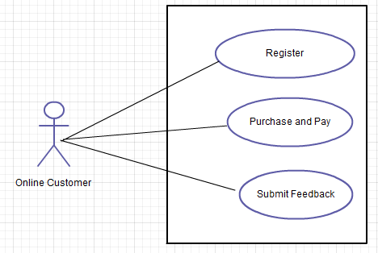

## Software Checklist

**Technology – Java Server Faces**

**Version – 1.2**

|  |  |
| --- | --- |
| **Implementation** | jquery-1.11.1.min.js, jquery-ui.js |
| **Tools** | Java 6, SDE 7.0/Notepad++ |
| **Server** | Tomcat 6 |

## Pre – requisite steps

1. Unzip the below content and place it in your hard disk



1. Open Eclipse IDE and import the below project using “Import -> Existing Projects into workspace” option
2. This acts as your code base to begin the case study development

## UI Prototypes Design Requirements

#### Screen 1 – Customer Registration

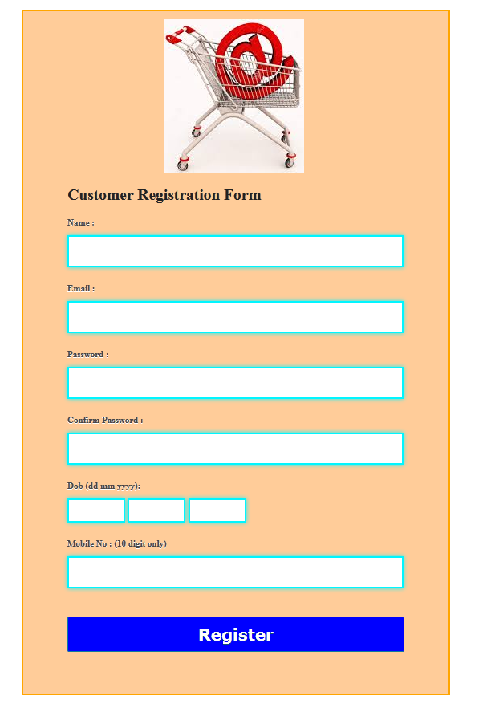

##### Business Rules

##### On Form Submission Check for Empty Elements and Change the border of the Elements in red color

1. Perform Age validation and make sure the age is above 18 to do registration
2. Both the password and confirm password should match each other
3. On entering the day part of the DOB, the control should allow only two digits
4. On entering the month part of the DOB, the control should allow only two digits
5. On entering the year part of the DOB, the control should allow only four digits

#### Screen 2 –Online Purchase and Payment

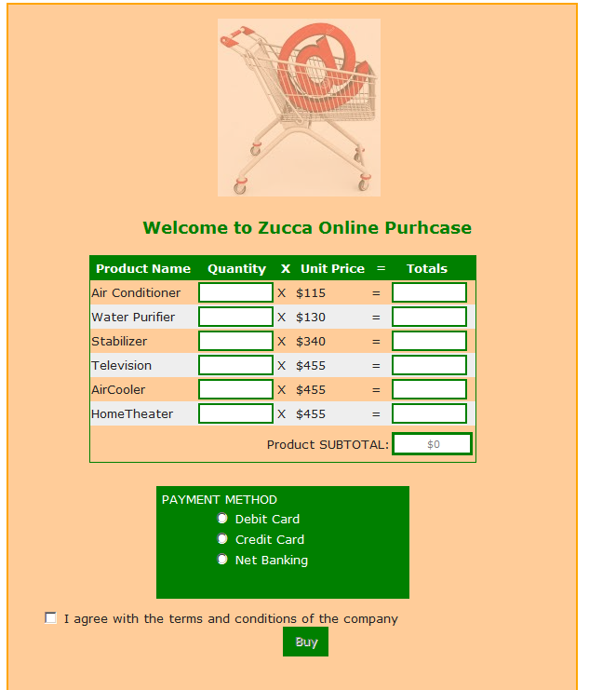

##### Business Rules

* On entering the quantity the total and subtotal need to be calculated and displayed automatically
* Card detail text boxes should display the text box title inside the controls
* Enable the “Buy” button only on accepting the terms and conditions. During the initial load of the page the button should be disabled. On checking /unchecking the checkbox the button need to be enabled/disabled

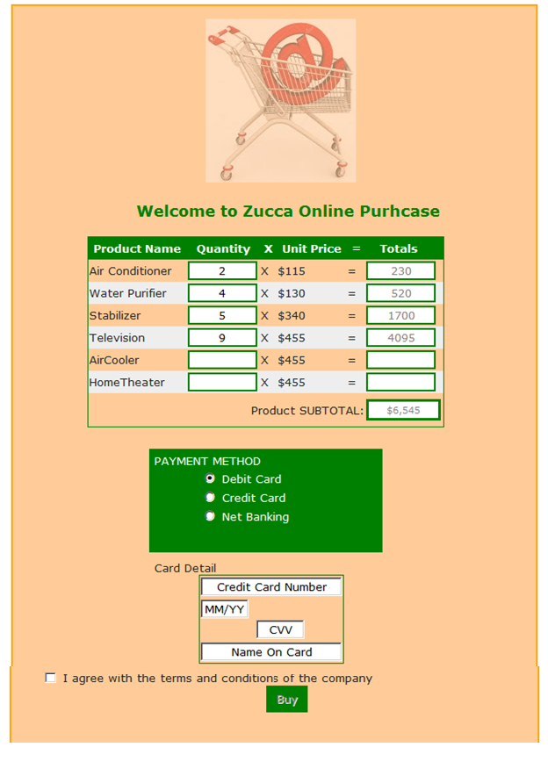

#### Screen 3 – Feedback Submission

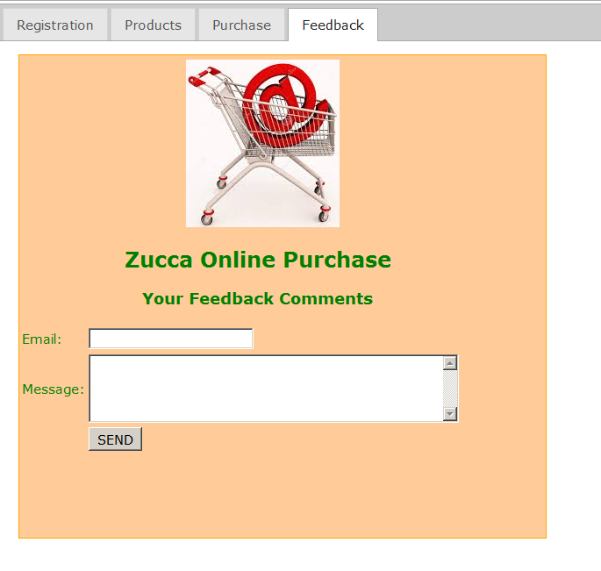

##### Business Rules

* On submitting the feedback form the details(email id and message) need to be stored in a json file.
* The response from the server should be displayed on the same feedback form as shown below

**The response from the server after submitting**

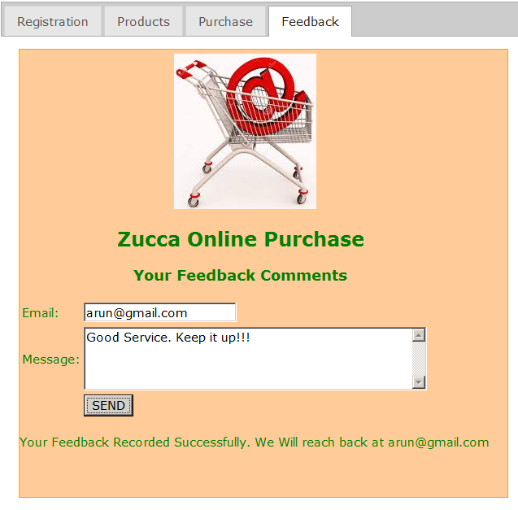

#### Software Design Requirements

### Component Design

#### Reusable Architectural Components

1. The Js files applicable for JQuery Implementation are available in the code base provided (in section “Pre-requisite steps”
2. No other external js should be added in the project

|  |  |  |  |
| --- | --- | --- | --- |
| **Date** | **Version** | **Author** | **Change Details** |
| 13 Oct 2014 | 1.0 | Ganeshamoorthy Chandrasekaran | Initial Version |
|  |  |  | Review and Update |